INDUSTRIAL INTERNET OF THINGS (IIOT) ARCHITECTURE AND APPLICATIONS

Configuration of Address Resolution Protocol (ARP) Using Cisco Packet Tracer- Summer Internship Project

Submitted By:
- Name: Divyabharathi K
- Register Number: 24BEC1549
- Department: Electronics and Communication Engineering
- College: Vellore Institute of Technology [Chennai]

Table of Contents
S.No | Contents | Page No.
1 | Aim | 2
2 | Problem Statement | 2
3 | Scope of the Solution | 2
4 | Overview / Architecture of the Solution | 2
5 | Required Components | 3
6 | Configuration Details | 3
7 | Procedure | 3
8 | Simulated Circuit | 4
9 | Execution Results | 7
10 | Output | 9
11 | Conclusion | 9

1. Aim
The aim of this project is to study the functioning of the Address Resolution Protocol (ARP) in a Local Area Network (LAN) using Cisco Packet Tracer. The project focuses on establishing communication between computers connected through a switch and understanding how IP addresses are translated into MAC addresses during data transmission.

2. Problem Statement
In a network environment, devices communicate using IP addresses, but actual data delivery within a LAN requires MAC addresses. When a device knows the destination IP address but does not know the corresponding MAC address, communication cannot proceed. A mechanism is therefore needed to determine the physical address associated with an IP address.
Address Resolution Protocol (ARP) performs this task by identifying the MAC address of a device from its IP address. This project demonstrates the configuration and operation of ARP using a simulated network created in Cisco Packet Tracer.

3. Scope of the Solution
This project is designed to:
- Understand the purpose and operation of ARP in a network.
- Configure and assign IP addresses to multiple computers.
- Establish communication through a network switch.
- Monitor ARP request and ARP reply messages.
- Verify network connectivity using ping commands.
- Examine ARP cache entries created during communication.

4. Overview / Architecture of the Solution

Components Used
- Personal Computers (PCs)
- 8-Port Network Switch
- Copper Straight-Through Ethernet Cables
- Cisco Packet Tracer

Network Architecture
The network consists of three computers connected to a single switch using Ethernet cables. All devices belong to the same subnet, enabling direct communication within the LAN.

Working Principle
- A source computer attempts to communicate with another computer in the network.
- The source device knows the destination IP address.
- If the destination MAC address is unknown, an ARP request is broadcast across the network.
- The target device responds with its MAC address through an ARP reply.
- The source device stores the received MAC address in its ARP table.
- Communication then proceeds using the obtained MAC address.

5. Required Components
S.No | Component | Quantity
1 | Personal Computer (PC) | 3
2 | 8-Port Switch | 1
3 | Copper Straight-Through Cable | 3
4 | Cisco Packet Tracer Software | 1

6. Configuration Details

IP Address Assignment
Device | IP Address | Subnet Mask
PC0 | 192.168.1.10 | 255.255.255.0
PC1 | 192.168.1.20 | 255.255.255.0
PC2 | 192.168.1.30 | 255.255.255.0

7. Procedure
Launch Cisco Packet Tracer and place three PCs from end devices option present in bottom right as second option along with one switch from network devices option present in bottom right as first option in the workspace.
Connect each PC to the switch from connnections option present in bottom right as forth option using Copper Straight-Through cables.
Assign IP addresses (for example 192.168.1.10) and subnet masks to all computers according to the configuration table.
Open the Command Prompt of PC0.
Display the ARP table by entering: arp –a
Test connectivity by executing: ping 192.168.1.20
Observe the newly added MAC address entry in the ARP cache and analyse the result.

8. Simulated Circuit

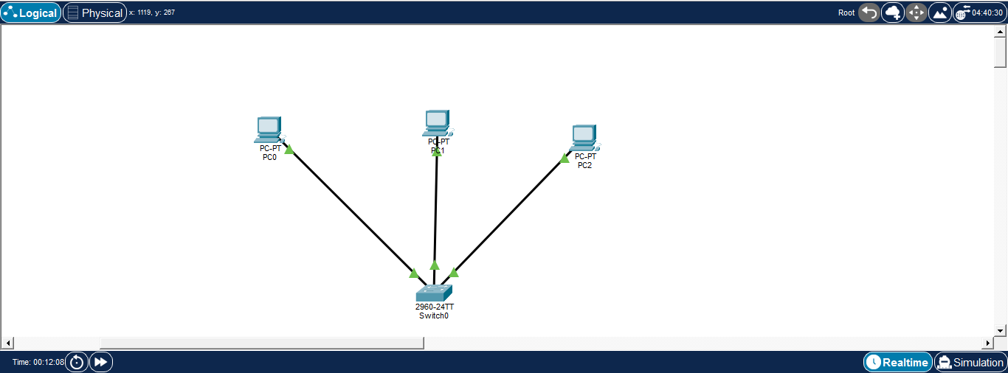
IP CONFIGURATION FOR PC0
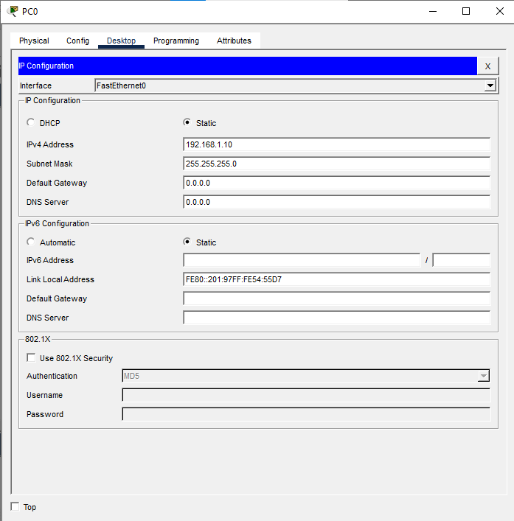
IP CONFIGURATION FOR PC1
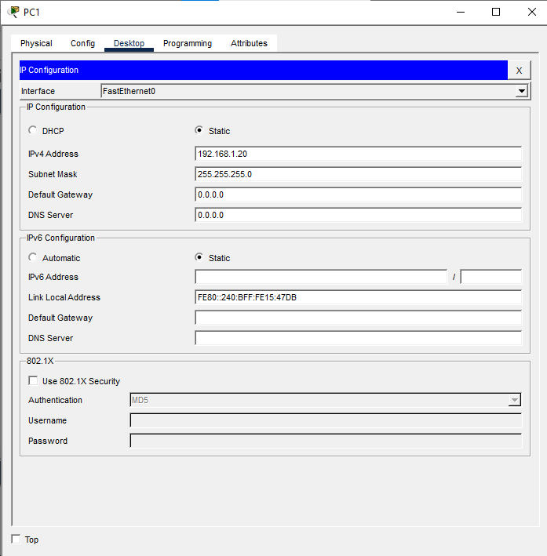

IP CONFIGURATION FOR PC2
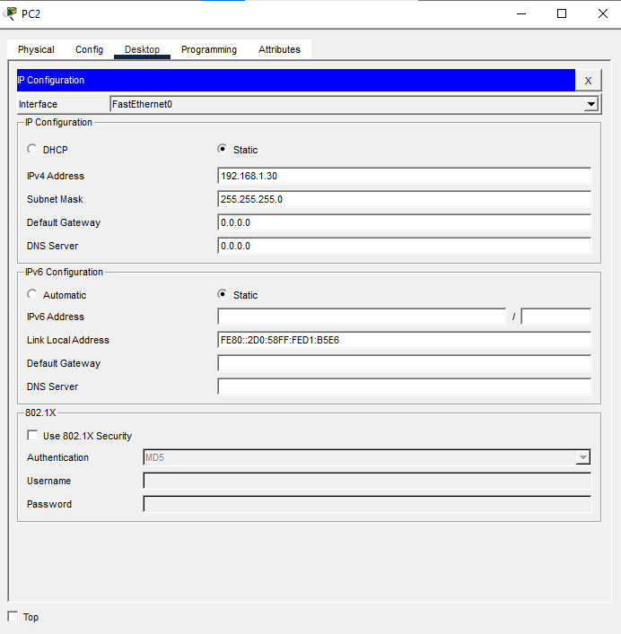
STIMULATION SETUP
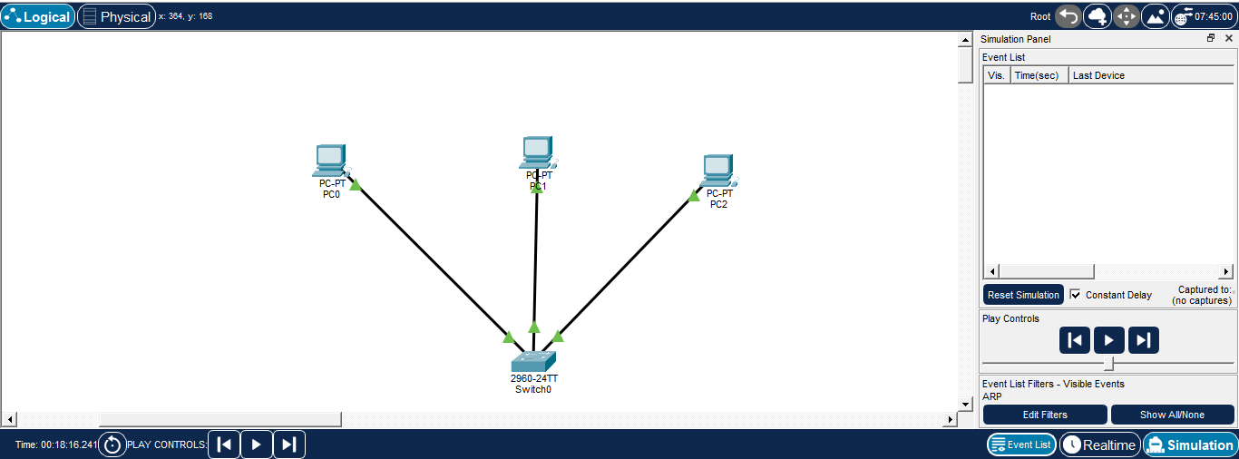
9. Execution Results

Successful ping from pc0 to pc1

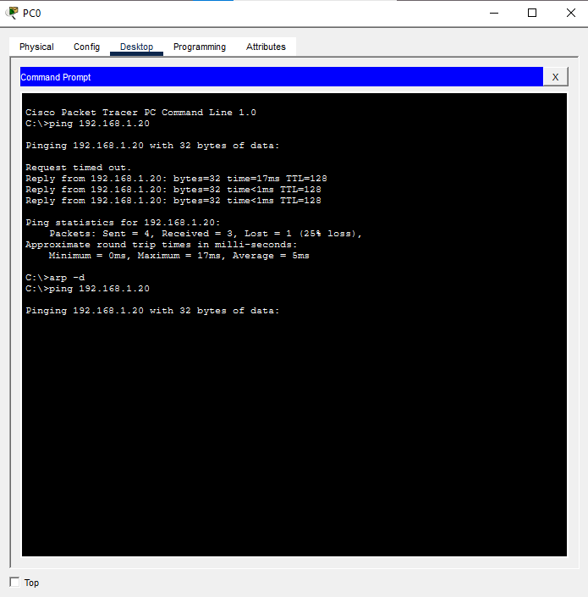

ARP request (PC1 is asking "Who has 192.168.1.20?" )

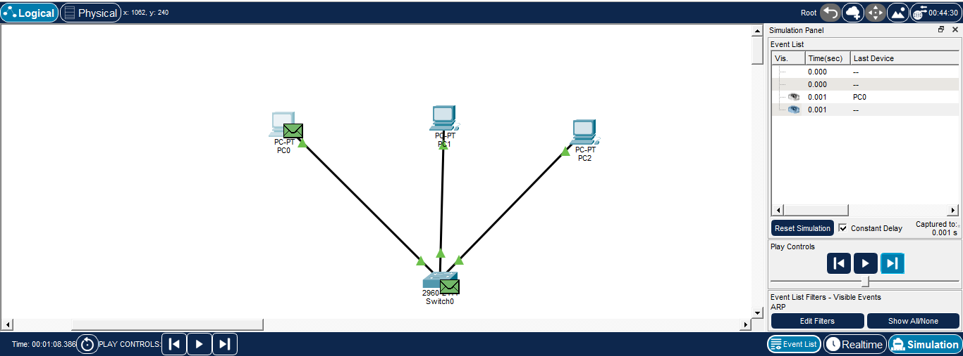
PC2 recieves the ARP Request and PC3 the ignores ARP Request because PC2 has the IP being asked for, so it will reply and PC3 doesn't have that IP, so it remove it
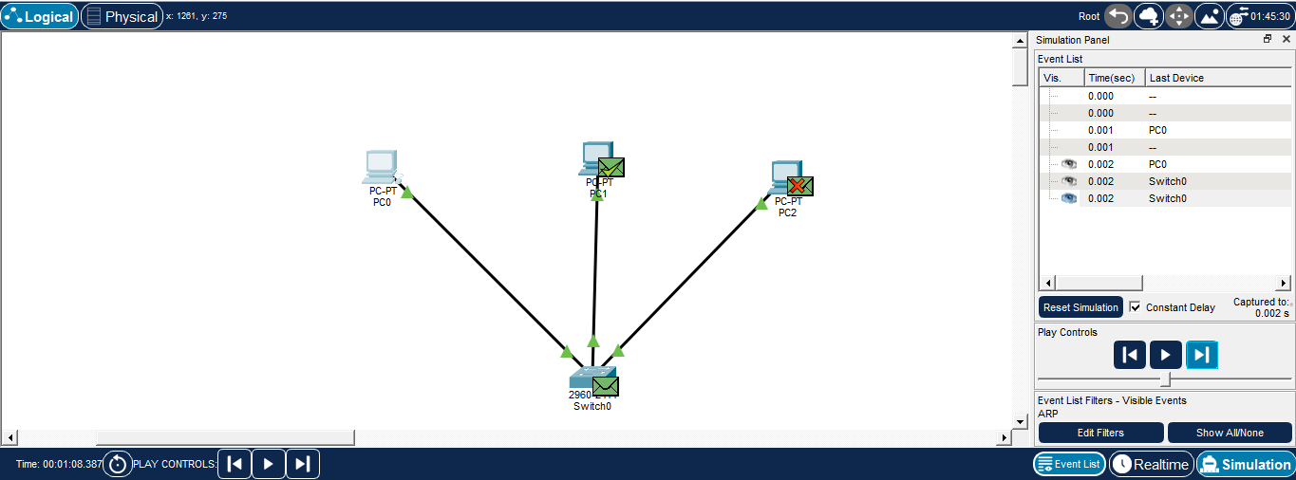

Arp Table
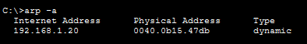
When PC0 attempted to communicate with PC1, an ARP request was broadcast to identify the destination MAC address. The target system responded with an ARP reply containing its physical address. After the MAC address was learned and stored in the ARP table, communication was successfully established. The ping command confirmed successful connectivity between the devices.
10. Output
- A LAN was successfully configured using Cisco Packet Tracer.
- Communication between network devices was established.
- ARP request and ARP reply operations were observed.
- ARP table entries were generated and verified.
- IP-to-MAC address mapping was successfully demonstrated.

11. Conclusion
This project successfully demonstrated the operation of Address Resolution Protocol within a Local Area Network. Through simulation in Cisco Packet Tracer, it was observed how a device obtains the MAC address associated with a destination IP address before transmitting data. The experiment provided a practical understanding of ARP and highlighted its importance in enabling efficient communication between devices on the same network.

